TASK 23 OUTPUT

1. Consider Employee table and write SQL commands.

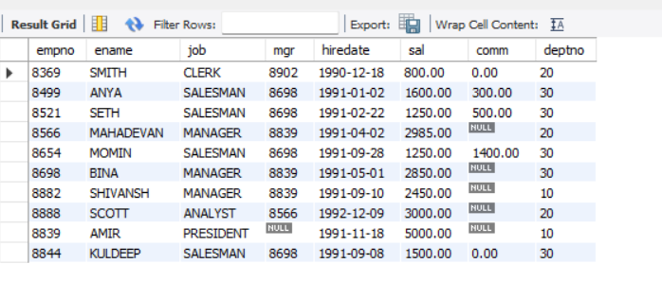

1. To display name and salary greater than or equal to 2200.

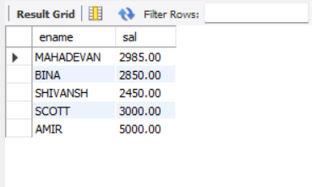

1. Write a quey to display details who not get commission.

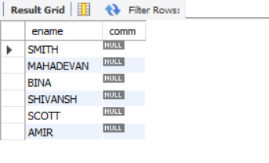

1. Employee salary range in range 2500 to 4000.

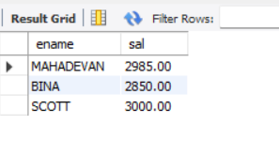

1. Who don’t have manager.

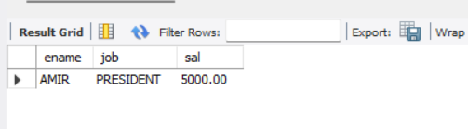

1. Whose name contains “a” as third letter

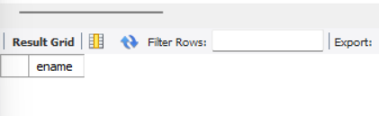

1. Name contains” in last alphabet.

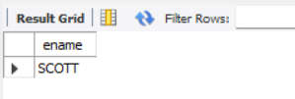

1. Write a program on JDBC and insert below data.

